
Application Note

Date: December 20th, 2022

Subject: Mobile - Global Override Imports
Host: Dillard’s
______________________________________________________________________

SAI has developed a method to import Point overrides into ControlIQ from an Excel file (xls, xlsx, csv, txt) through M.ControlIQ.Com.

It allows the user to Drag and Drop a spreadsheet file onto the form or 'Choose a file' to select a file. The file size must be less than 50KB (this will hold about 2000 records). All edits to the data must be completed in the spreadsheet prior to importing. If the spreadsheet contains multiple sheets, only the 1st sheet is imported. Unlike Schedule imports, an email will NOT be sent following the import.

All imported data can be seen/edited from the other areas in M.ControlIQ.Com (Points, Groups, etc.).

- There must be a header row with the column names
- There must be a column called 'Alias'
There must be a column called 'Value'
- There must be a column called ‘Action’
- A ‘Duration’ column is optional.

Any other columns will show on the mobile screen but will be ignored in the import.
We ‘recommend’ as few columns as possible to avoid confusion.

Examples are provide below.

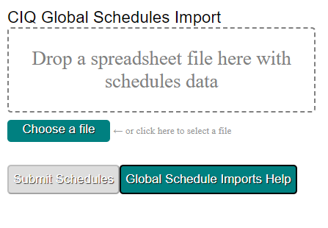

Some Examples:

Alias | Value | Action | Duration
S378Sched0 | On | Set | 8
S379Sched0 | Off | Set | 8
S378R1CSP | 72.5 | Set

Note:
The contents of the Value Column is:
On – Constant = 1
Off – Constant = 0
A numerical entry

The contents of the Action Column is:
Set – Set it into override condition (S, Override, SOP also allowed)
Clear – Clear the override condition (C, COP also allowed)
COSP – Clear Override Setpoint (follows a SOSP)
SOSP – Set Override Setpoint
SSP – Set a setpoint (Change) (Setpoint, Change also allowed)

The contents of the Duration Column (Optional) is in Hours
If the duration cell is empty it is Overridden ‘Forever’
30 minutes would be .5

