**Application Note: Mobile – Global Processes**



**Date:** March 18th, 2022

**Subject:**  How to setup Global Processes in Mobile

**Host:** Spere

______________________________________________________________________

SAI has added capabilities for any site to use Global Parameters in Mobile. This only works in Mobile V6 or greater and Proc version 5.0.1.18.

The Global Area should be used with extreme caution. The user could make changes that affect many (all) devices.

Requirements:

* CIQProc v5.0.1.18 or greater
* Mobile v6.0 or greater
* Multiple Properties defined at a site (Properties Table)
* Local User with “Global” bit set
* Alarm Process set with ‘Global’ Alias

The intent of Global is to affect changes at a Property level across many devices. A site must be defined with multiple properties for this to be enabled.

A local user(s) must have the “Global” bit set in their viewmask (Bit 21). The ControlIQ ‘built-in’ user does not have this capability.

You must define at least one Alarm Process with an Alias as “Global”, an OutputType as “Email” and a valid email address for this to be active. These email address will be sent a message every time Global is used to change parameters. The following is an example of an email transmitted:

The following Global Setpoint Changes were made by: NZ*******

Please review for authenticity and accuracy.

Occupied Cooling Setpoint: 70 was applied to the following Locations:

S101, S102, S103, S217, S224, S228, S702, S705, S910

**Properties** Table:

A new field, ‘Parent’, was added to the properties table. This is the textual definition of the division or ownership of each property. Global will display a unique list of these in the global area. Put “All” in the parent field of the “Global” property

**Global_Xrefs** Table:

This is a new table added with Proc version 5.0.1.18. Proc will build the structure of this table automatically. This table defines the global types supported and must be an exact match for it to be included in the Global submenu.

Fields:

Ordinal – The display order in Global. This is a one-up number starting with 0 for each type. “All” is supported in some schedule process. If “All” is used its Ordinal needs to be set to -1

Type - This pertains to the Global submenu. The supported types are:

Sched – Schedules for Creating and Deleting Exception Schedules

SetPoint – Altering AOs used for Setpoints

TimeZone – Sync Time across Controllers

Description – The description to be displayed in the drop down

AliasMatch – The Points.Alias must match this pattern to be included in the list

Fields used in Setpoint Type only:

Steps – How many ‘options’ will be available to pick from.

Increment – The increment between values of the options.

Seed – The Starting value in the options list.

In Code this looks like:

For X=0 to Steps Step Increment

Value = X+Seed

Next X

Format – The display format for the ‘options’ list.

Note: If a ‘Type’ is omitted, it will not be available in the Global Submenu

The following is an example of the table.

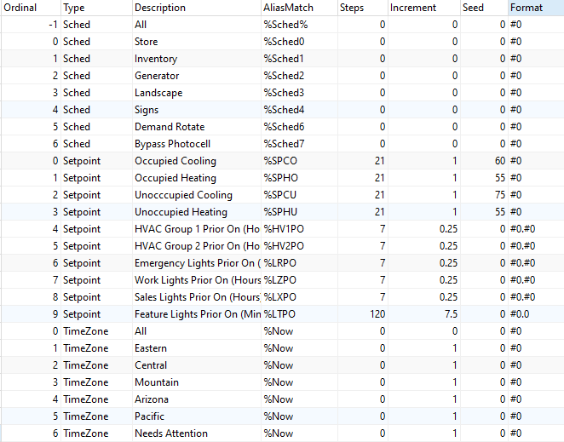

In this example, if Global Setpoint was selected and the user choose ‘Occupied Cooling’ the result table will inclued any alias that ends with ‘SPCO’ (and matches the ‘Parent’ chosen). There will be 21 options available (Steps / Increment) starting with 60 (Seed) with an increment of 1. (60, 61, 62, 63…)

If ‘HVAC Group 1 Prior On (Hours)’ is selected, there wll be 28 options available (Steps / Increments) starting at 0. (0.00, 0.25, 0.50, 0.75, 1.00…).