ControlIQ Application Note

Number: 18
Date: June 30th, 2011
Subject: Temperature Sensor Calibration for ASIC/1-6000
Subsystem: ASIC/1
________________________________________________________________________

To adjust the calibration for a temperature sensor in an ASIC/1-6000 VAV controller,

1st Open Proc and pause the subsystem correlating to the VAV controller to be calibrated.

2nd Open ASI Expert, type in the address for that VAV controller, and click Enter, click Ok at the next screen to further open the controller.

3rd Once in the controller, open the “Other Views” tab, select “Input Summary”

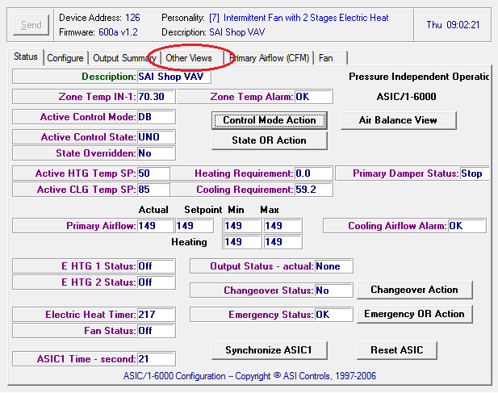

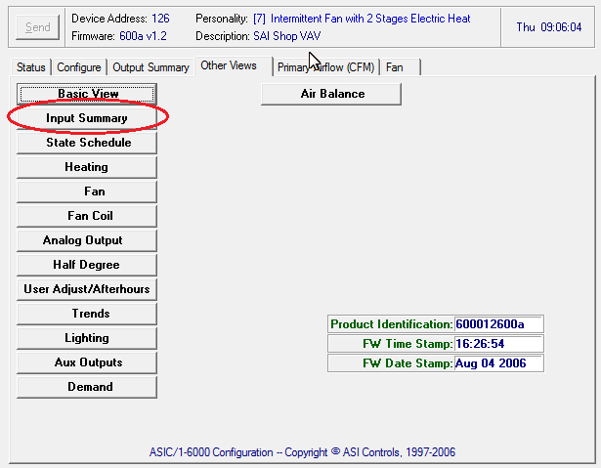

4th Under the “Input Summary” tab, top of the second column will be an option for “Zone Sensor Bias” in green. In the box next to it type the desired temperature calibration. Example: type “2” for 2 degrees of bias up, so 68 degrees would read as 70. Type “-2” for 2 degrees of bias down, 68 degrees would read as 66.

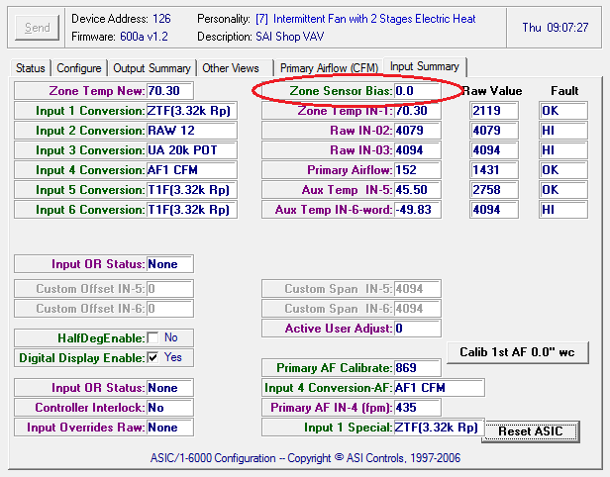

5th Close ASI Expert, and un-pause the Proc subsystem.

6th Repeat as necessary.

