ControlIQ Application Note

Number: 19
Date: June 30th, 2011
Subject: Temperature Sensor Calibration for ASIC/2-7540
Subsystem: ASIC/2
________________________________________________________________________

To adjust the calibration for a temperature sensor in an ASIC/2-7540 controller,

1st Open Proc and pause the subsystem correlating to the controller to be calibrated.

2nd Open ASI Expert, type in the address for that controller, and click Enter, click Ok at the next screen to further open the controller.

3rd Once in the controller, click on “INP-5 (Input)” to expand the list.
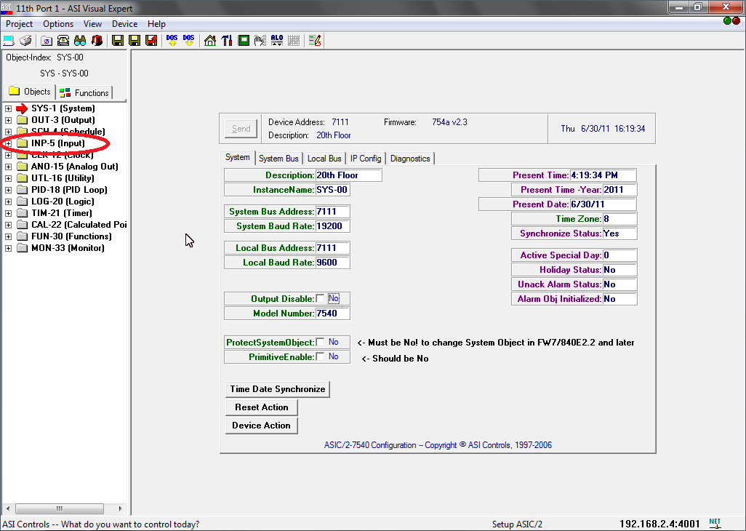

4th Under the “INP-5 (Input)” list, select the desired temperature sensor that needs calibrated. Once you click the input a red arrow will show point to the input selected.
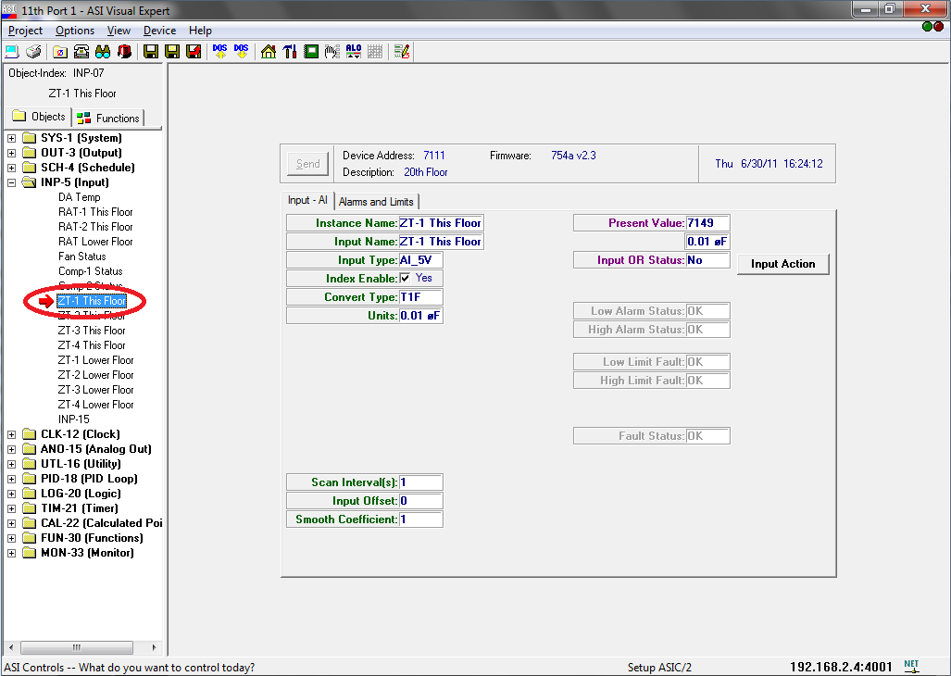

5th Once the desired input is selected the configuration screen will appear. In the bottom left hand corner is “Input Offset” option in green. In the box next to it type in the desired temperature calibration. NOTE: For ASIC/2-7540’s the number MUST be in 100’s format. Example: type “200” for 2 degrees of offset up, so 68 degrees will read as 70. Type “-200” for 2 degrees of offset down, so 68 degrees will read as 66.
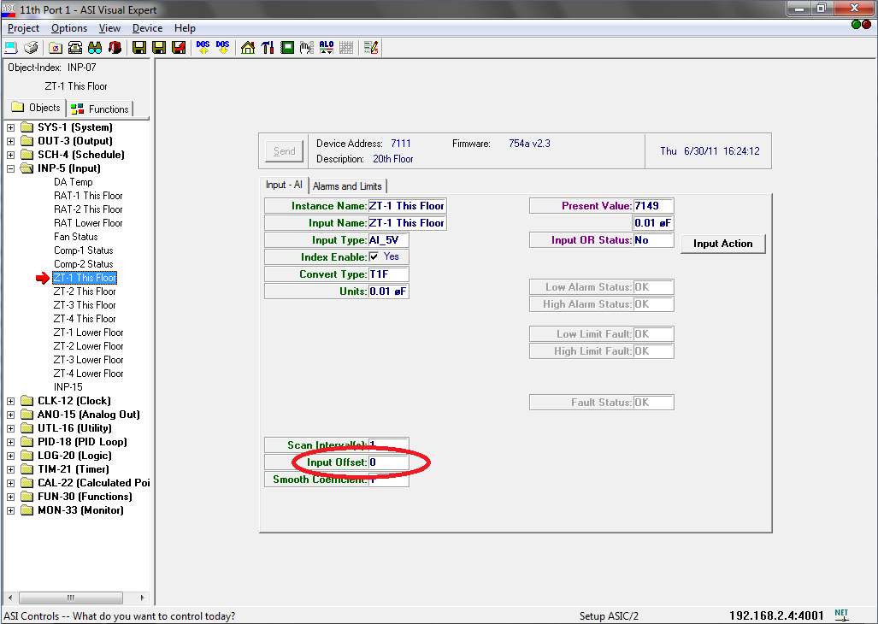

5th Close ASI Expert, and un-pause the Proc subsystem.

6th Repeat as necessary.

