
Go To Assist Application Note

Number: 1
Date: November 26th, 2012
Subject: Go To Assist Preference Settings
________________________________________________________________________

Go To Assist has a preference that “locks” the computer upon disconnect. That means the customer has to enter the password in order to gain access to the computer. If the customer is not used to this behavior it could potentially result in a support call. To prevent the computer from locking it needs to be set in the preferences for your login. Once this is set once all of the Go to Assist applications will apply the settings. To do so follow these instructions:

- On a workstation open Go To Assist Expert

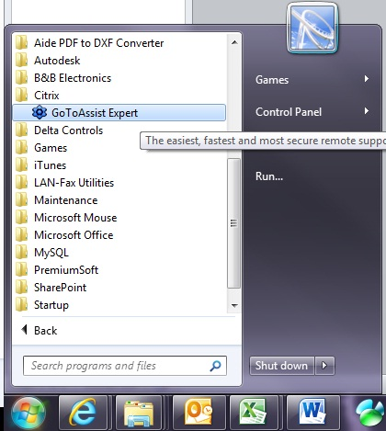

- Once open, select “Tools” and then “Preferences”
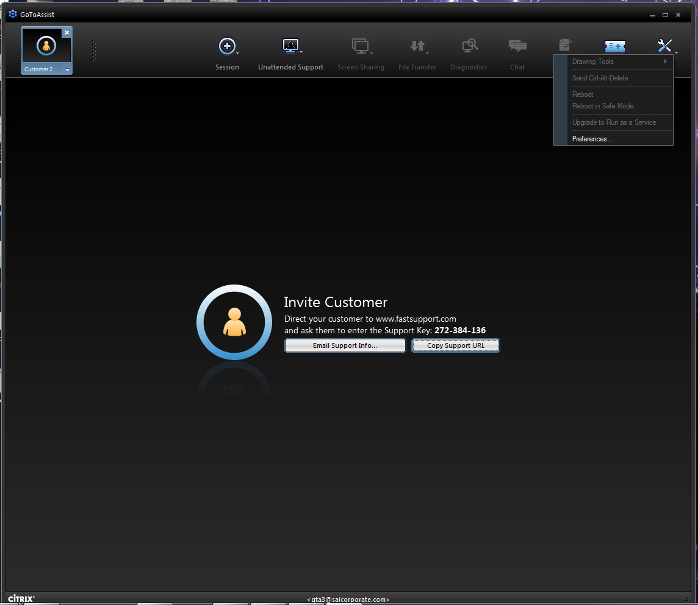

- Select “Unattended Support” tab from the top

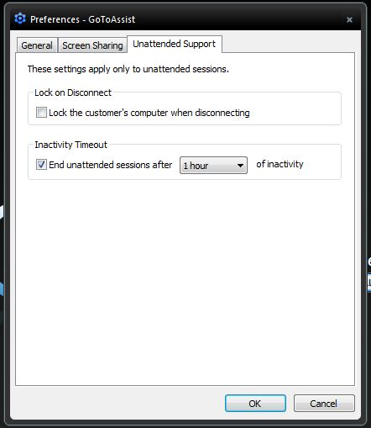

- Make Sure the “Lock customer’s computer when disconnecting” box is Unchecked
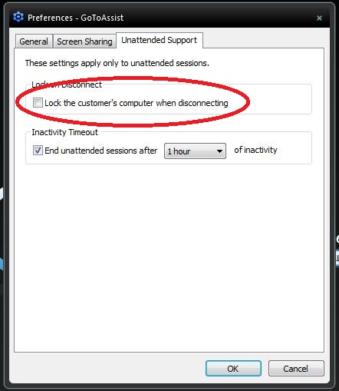

These settings are based on the user that is logged in. In order for the iPad app and other computers to pick up these changes they have to be ended.


- To end the iPad app, Double Click the Home button. This brings up the apps that are running in the background
- Tap and hold the Go To Assist app until appears in the upper left hand corner.
- Tap on the so the Go To Assist app icon disappears.

It is a good idea to run the iPad app to make sure the change has remained.
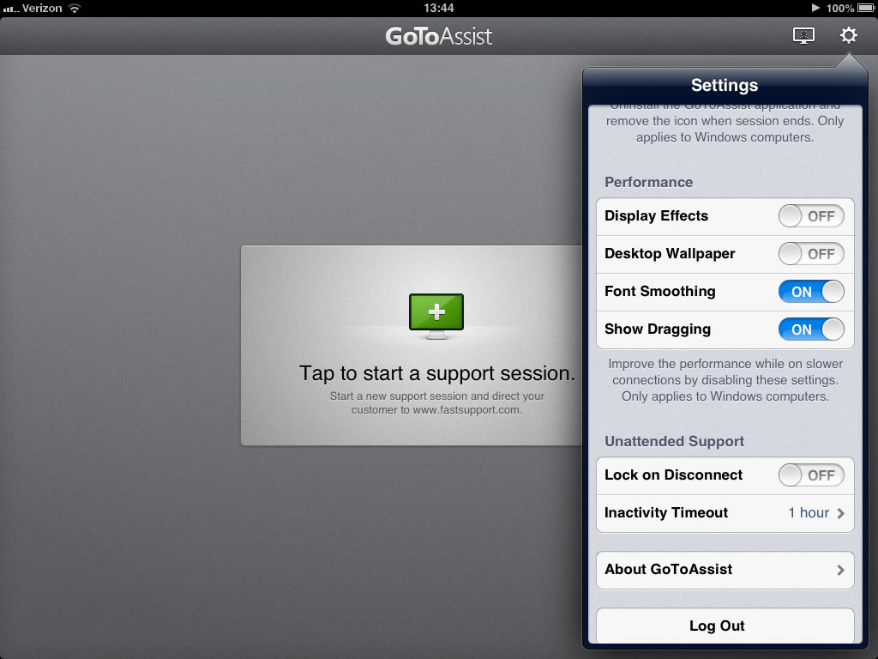
- Open the Go To Assist app
on the iPad
- Login
- Select the Gear icon in the
upper right hand corner
- Scroll down until
“Lock on Disconnect”
is displayed
- Make sure it is set to OFF
(means the box was
unchecked on the computer).

Go To Assist must be ended on other computers running with your login. This includes home computers.

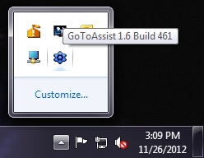
- If Go To Assist is running, the icon will be in the system tray in the lower right hand corner.

- Right Click the icon and select “Exit”
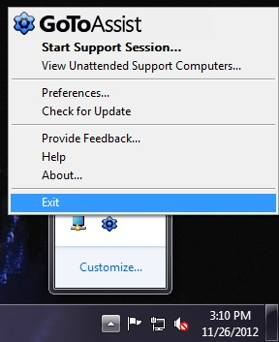

This will end Go To Assist. To start it again repeat the first step. Make sure the settings have updated.

